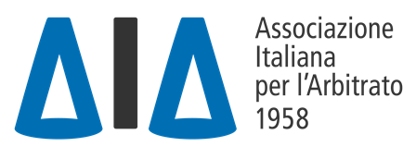 |  | 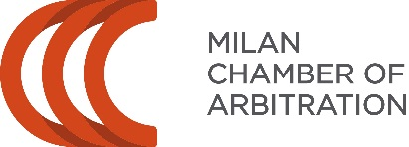

VII AIA-CAM PRE-MOOT
2nd Virtual Edition
3-4 March 2022

Info:
The AIA-CAM Pre-Moot Organisers
aiacam.premoot@gmail.com
www.facebook.com/aiacampremoot

TEAM REGISTRATION FORM
please fill in and return by 19 December 2021 at the latest
via e-mail: aiacam.premoot@gmail.com

- [Name of the University]
- [Team contact person (name, telephone number and e-mail address)]
- [Names of coaches, their respective availability to act as arbitrator, and their email address]
- We hereby certify to be officially enrolled in the Willem C. Vis International Commercial Arbitration Moot

We cannot participate at the practice rounds (cross out where you cannot join the hearing session):

 | 3 March 2022 | 4 March 2022
14.30-16.00
16.30-18.00

***If any of the above-mentioned time-slots does not fit your team’s arrangements, please indicate so in the Comments section of the form.

Are your coaches available to arbitrate?

If yes, please indicate here below the availabilities

Coach 1 can arbitrate on:

 | 3 March 2022 |  |  | 4 March 2022
14.30-16.00 Round 1 |  |  | 14.30-16.00  Round 3
16.30-18.00  Round 2 |  |  | 16.30-18.00  Round 4

Coach 2 can arbitrate on:

 | 3 March 2022 |  |  | 4 March 2022
14.30-16.00 Round 1 |  |  | 14.30-16.00  Round 3
16.30-18.00  Round 2 |  |  | 16.30-18.00  Round 4

LIST OF TEAM MEMBERS:
Please specify the approximate number of team members and their email addresses

COMMENTS SECTION

