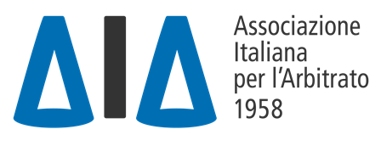
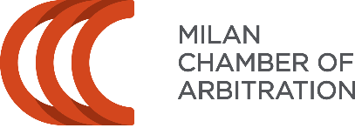

VIII AIA-CAM Pre-Moot

VIII AIA-CAM PRE-MOOT
23-24 February 2023

CALL FOR ARBITRATORS
Sponsored by

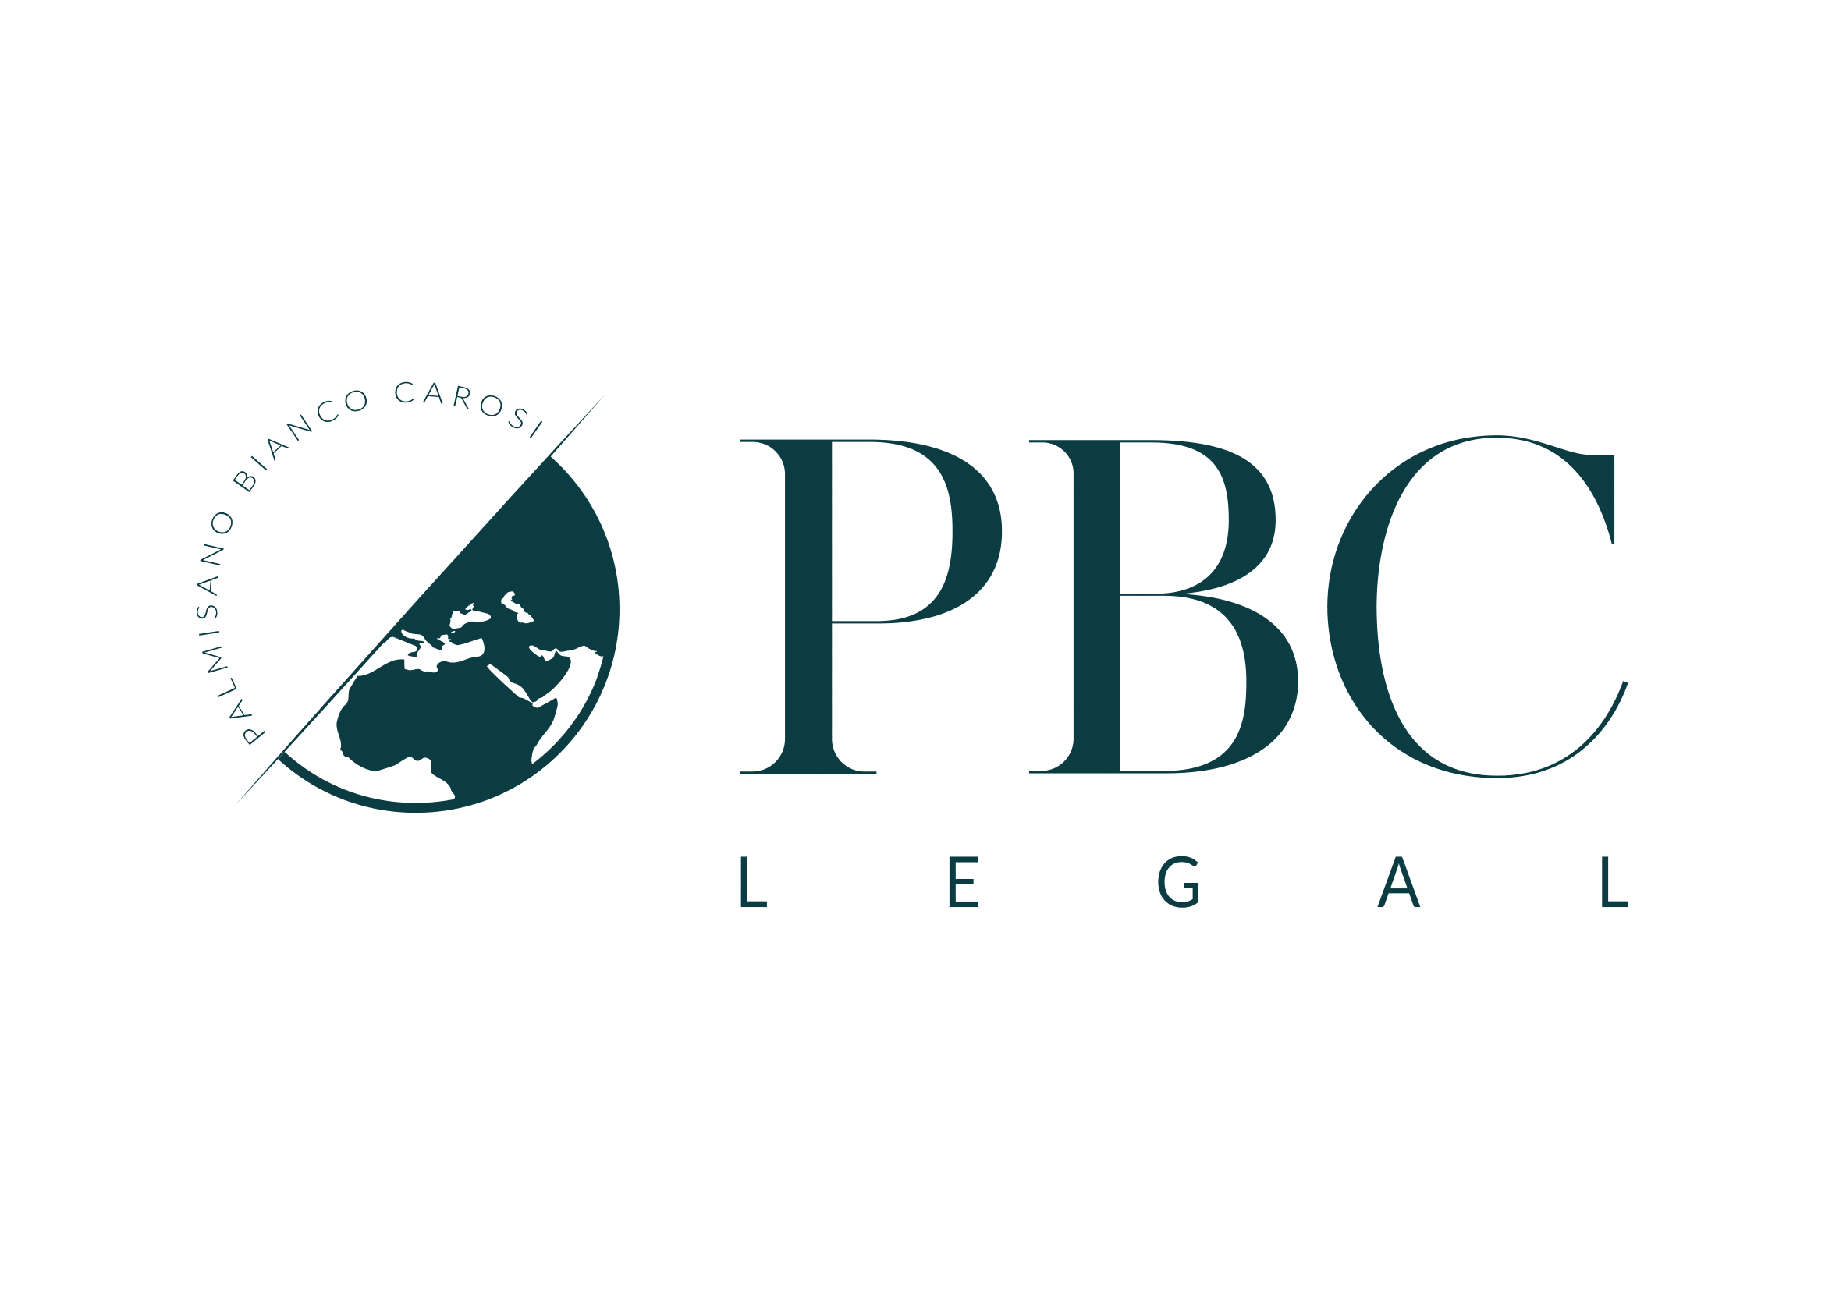
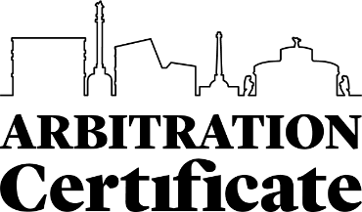
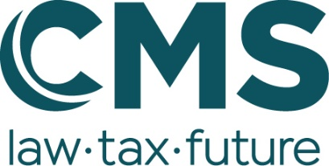
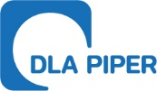

Rome-Milan, 24 January 2023
Dear all,
The Italian Association for Arbitration (AIA) and the Milan Chamber of Arbitration (CAM) have been jointly organizing the AIA-CAM Pre-Moot for teams participating in the Willem C. Vis International Commercial Arbitration Moot.
We are proud to announce that the VIII edition of the AIA-CAM Pre-Moot will take place in Rome (Roma Tre University, via Ostiense, 159) on 23 and 24 February 2023.
We are glad to invite you to join us as an arbitrator by submitting your availability and cross out one or more of the following options:

24 February 2023 | Time | Available?
Round 1 | 10.00-11.30 CET
Round 2 | 12.00-13.30 CET
Round 3 | 14.30-16.00 CET
Round 4 | 16.30-18.00 CET

Please indicate the description, if any, that follows your name by clarifying:
- PARTNER / ASSOCIATE / LAWYER / OF COUNSEL / TRAINEE AT [NAME OF YOUR LAW FIRM] IN [CITY]
- PROFESSOR OF [...] AT [..] UNIVERSITY.
- FURTHER OR DIFFERENT QUALIFICATION [...]

Once we receive your availability, please consider that we rely on your commitment.
The name of the teams that you arbitrate will be provided shortly before the AIA-CAM Pre-moot takes place.

Please fill in and return via e-mail at
aiacam.premoot@gmail.com

