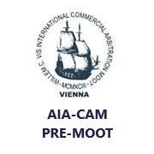

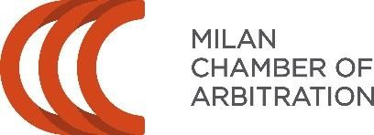

AIA-CAM PRE-MOOT

Criteria for Admission of Teams

The Italian Association for Arbitration (AIA) and the Milan Chamber of Arbitration (CAM) have been jointly organizing the AIA-CAM Pre-Moot for teams participating in the Willem C. Vis International Commercial Arbitration Moot for many years.

During these years, the number of team asking to participate and those who actually participated, has constantly increased.

The Organising Committee has drafted a list of criteria in order to transparently disclose how teams are selected to join the Pre-Moot, with the aim of granting a proficiency educational experience. In any event, AIA and CAM reserve the right to take any adequate measures in order to ensure the good outcome of the Pre-Moot in terms of confrontation of different legal backgrounds.

- AIA and CAM reserve the right to limit to a maximum number the teams the organisers would accommodate each year;
- The number of Italian teams may be limited accordingly in order to ensure a balance on the different background of the participating teams;
- The enrolling teams shall be officially registered for the Willem C. Vis Moot;
- Priority will be granted to teams whose escorting coach/es is/are available as arbitrator, at least when the team is resting;

The AIA-CAM Pre-Moot Organisers aiacam.premoot@gmail.com www.facebook.com/aiacampremoot

- The teams that ranked in the top 5 positions of the previous edition have preemptive rights to renew their registration for the AIA-CAM Pre-Moot;
- In the event of teams coming from the same country, the organisers will give priority to those who are participating for the first time in the AIA-CAM Pre-Moot or, in the alternative, who would send the registration form before the other.

