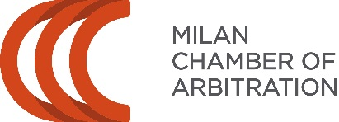

VIII AIA-CAM PRE-MOOT
23-24 February 2023

Info:  The AIA-CAM Pre-Moot Organisers  aiacam.premoot@gmail.com  www.facebook.com/aiacampremoot | Venue:  Roma Tre University, Department of Law  Via Ostiense, 159 – Rome  Metro B – San Paolo  https://goo.gl/maps/nL6QrzTV9YL2

TEAM REGISTRATION FORM
please fill in and return by 18 December 2022 at the latest
via e-mail: aiacam.premoot@gmail.com

- Name of your University:
- Team contact person (name, telephone number and e-mail address):
- Names of coaches and their email address:
- We hereby certify to be officially enrolled in the Willem C. Vis International Commercial Arbitration Moot

We cannot participate at the practice rounds (cross out where you cannot join the hearing session):

 | 23 February 2023 | 24 February 2023
9-13 | No hearings
14-18 | Arbitration conference and Opening

***If any of the above-mentioned time-slots does not fit your team’s travel arrangements, please indicate so in the Comments section of the form

LIST OF TEAM MEMBERS:
Please specify the number of team members and their email addresses

LIST OF COACHES AVAILABLE TO ARBITRATE (please note that the Organisers will try their best to avoid asking to arbitrate when the team is participating in a hearing)

COMMENTS SECTION

